Sam & Mitzi
Lewis & Irene
Design and made by Sally Ablett
Size 49" x 49"
Requirements
- A106.1 – daisy on linen
- A106.3 – blue on white
- A107.3 – contented cat mitzi 0n dark blue
- A108 1 – sam & mitzi on linen
- A108.2 – sam & mitzi on white
- A109.1 – nose to nose sam on linen
- A109.2 – nose to nose sam on white
- A110.2 – dotty flower on red
- BB46 – light green
- BB49 – ink
- BB45 – aquamarine
The warm company wadding 55" x 55"
Backing 55" x 55"
All measurements include ¼" seam allowances; press each seam as you go.
Cutting
From each of the fabrics 1, 2, 3, 4, 5, 6, 7, 8, 9 and 10 cut
Look at the main diagram to see which way you will cut your fabric from top left to bottom right or bottom left to top right.
5 x 5⅞" x 5⅞" cut in half diagonally once
(You will have one triangle over from each colour)
From fabric 11 cut
45 x 5⅞" x 5⅞" cut in half diagonally once
2 x 2½" x 50½" (sides)
2 x 2½" x 49½" (top and bottom)
Making up.
Sew two small triangles together to make a square using your background fabric with each colour fabric.
Make 90 blocks in total.
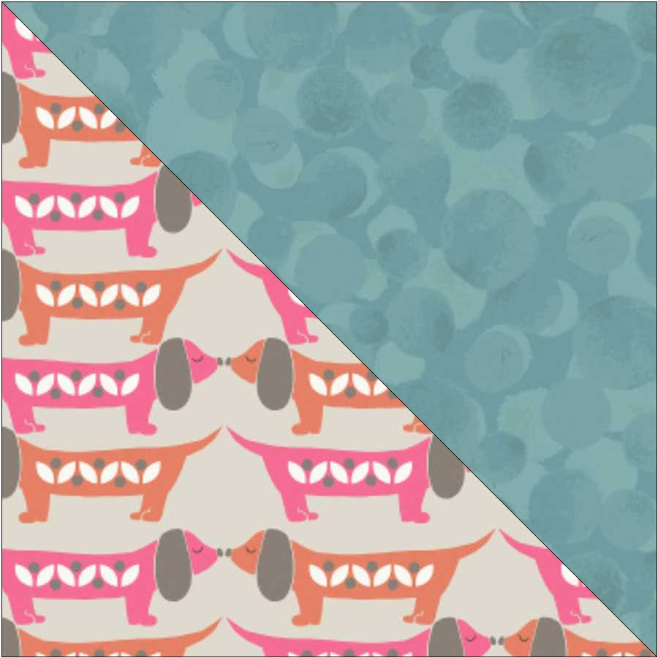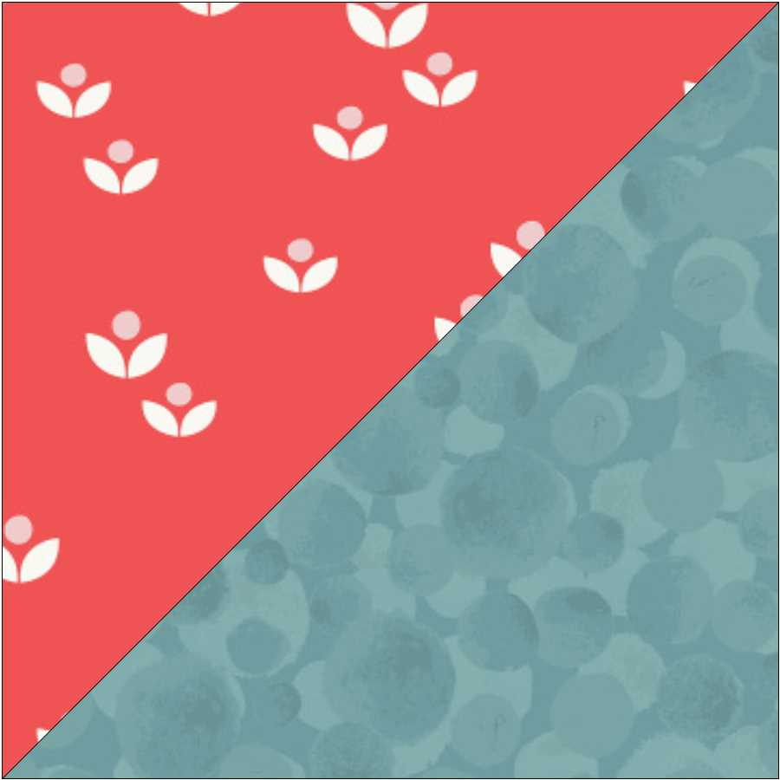
Blocks cut top left to bottom right. Bottom left to top right.
When you have make all your blocks lay them out as in the main diagram.
Sew in rows and then sew the rows together.
Add the borders sides and then top and bottom.
Sandwich the quilt together top, wadding and backing. Quilt by hand or machine.
Trim off the wadding and backing, Sew the binding using your left over pieces of fabric.
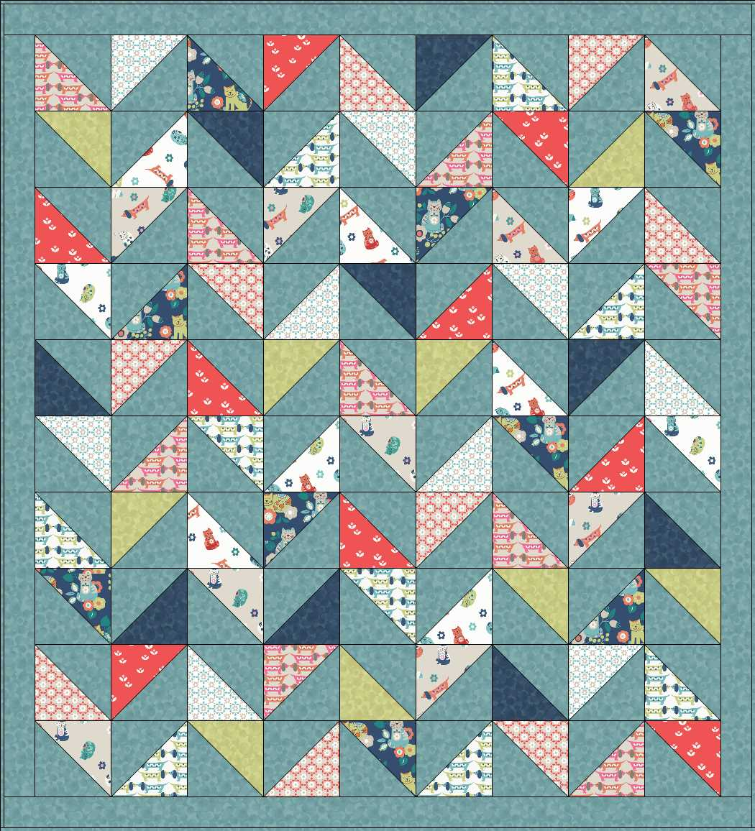
Main diagram

